A PROJECT REPORT

ON

**“Robotic Arm”**

SUBMITTED IN PARTIAL FULFILLMENT OF THE REQUIREMENTS FOR THE DIPLOMA IN

# **COMPUTER SCIENCE & ENGINEERING**

SUBMITTED BY

|  |  |  |
| --- | --- | --- |
|  | **NAME OF THE STUDENT** | **REGISTRATION NO.** |
| 1 | K Rajtilak | F22026007039 |
| 2 | Bikram Keshari Dash | F22026007024 |
| 3 | MD Riyasat Ali | F22026007045 |
| 4 | Biswajeet Muduli | F22026007026 |
| 5 | Gargee Dash | F22026007036 |



**DRIEMS POLYTECHNIC, TANGI, CUTTACK ACADEMIC YEAR**

**2024-2025**



# DRIEMS POLYTECHNIC

***CERTIFICATE***

This is to certify that the work in this Project Report entitled “Robotic Arm”

K Rajtilak (F22026007039), Bikram Keshari Dash (F22026007024), MD Riyasat Ali (F22026007045), Biswajeet Muduli (F22026007026) Gargee Dash (F22026007036) have been carried out under my supervision in partial fulfillment of the requirements for the Diploma in Computer Science & Engineering during session 2024-2025 in Department of Computer Science & Engineering of DRIEMS POLYTECHNIC and this work is the original work of the above students.

**Er. Jyoti Ranjan Nayak**

**(Project Guide)**

***ACKNOWLEDGMENT***

This project is done as a semester project, as a part course titled

**“PROJECT WORK PHASE -II”.**

We are really thankful to our Principal **Dr. Tapaswini Sahu** and the **HOD, Er. Ladu Kishore Sahoo, Department of Computer Science & Engineering, DRIEMS, Polytechnic, Tangi, Cuttack** for his invaluable guidance and assistance, without which the accomplishment of the task would have never been possible.

We also thank **Er. Jyoti Ranjan Nayak** for giving this opportunity to explore into the real world and realize the interrelation without which a Project can never progress. In our present project we have chosen the topic- **“Robotic Arm”.**

We are also thankful to parents, friend and all staff of **Department of Computer Science & Engineering** for providing us relevant information and necessary clarifications, and great support.

|  |  |  |
| --- | --- | --- |
|  | **NAME OF THE STUDENT** | **REGISTRATION NO.** |
| 1 | K Rajtilak | F22026007039 |
| 2 | Bikram Keshari Dash | F22026007024 |
| 3 | MD Riyasat Ali | F22026007045 |
| 4 | Biswajeet Muduli | F22026007026 |
| 5 | Gargee Dash | F22026007036 |

**ABSTRACT**

This project centers on the design and development of a 3D-printed robotic arm, incorporating advanced IoT capabilities for wireless control and task automation. The robotic arm was designed Blender, a versatile 3D modelling tool, which allowed us to refine the structural details and ensure an efficient design optimized for real-world applications. This process highlights our proficiency in 3D modelling and the ability to convert creative designs into functional prototypes. The robotic arm’s functionality is powered by the ESP32 microcontroller, which serves as the core of the system. Known for its reliability and versatility, the ESP32 provides a robust platform for seamless wireless communication and precise control of the robotic arm’s movements. To enable intuitive and efficient user interaction, the ESP32 is configured as a Wi-Fi Access Point, eliminating the need for an external router. Users can connect directly to the robotic arm through a custom-built web interface accessible on any Wi-Fi-enabled device. This interface is built using WebSocket technology, which ensures low-latency communication and real-time control. As a result, users can issue commands and receive instant feedback, making the robotic arm’s operation both smooth and responsive. This real-time control is particularly useful in scenarios where precision and timing are critical.

The robotic arm is equipped with 4 servo motors, each dedicated to controlling a specific joint or axis. These include the base, shoulder, elbow, and gripper, which collectively allow the arm to perform a wide range of movements. The precision offered by the servo motors ensures that even sensitive tasks can be executed with ease. To further enhance the arm’s functionality, the system features a motion recording and playback capability. This allows users to record a sequence of movements and replay them repeatedly, making the arm ideal for tasks that require consistency, such as assembly line operations or pick-and-place applications.

Our project draws on an interdisciplinary approach, combining knowledge and skills from microcontroller programming, servo motor control algorithms and robotics. The ability to wirelessly control the robotic arm and automate tasks demonstrates the seamless integration of IoT and robotics technologies. This integration opens up practical applications in various fields, including industrial automation, prototyping, and educational robotics. For instance, the robotic arm could be used in factories for repetitive assembly tasks, in laboratories for precise handling of samples, or in educational settings to teach students about the principles of robotics and automation. Beyond its practical applications, this project showcases our ability to tackle complex engineering challenges. The design and implementation process required a deep understanding of both hardware and software systems. From designing the arm in Blender to programming the ESP32 for real-time communication and control, every aspect of the project demanded a high level of technical skill and attention to detail. The challenges we encountered during development, such as ensuring the smooth operation of servo motors and achieving reliable wireless connectivity, provided valuable learning experiences that have further enhanced our problem-solving abilities.

In summary, this project is a comprehensive demonstration of our technical proficiency and innovative thinking. It exemplifies our ability to bridge the gap between theoretical knowledge and practical application, resulting in a functional system that addresses real-world needs. By leveraging IoT and robotics technologies, the robotic arm serves as a testament to the potential of automation to improve efficiency and productivity in various domains. This project not only highlights our technical skills in design and programming but also underscores our commitment to exploring the possibilities of emerging technologies in robotics and IoT.

**LIST OF FIGURES**

|  |  |
| --- | --- |
| Figure 1 | Work flow diagram of the Project |
| Figure 2 | Block diagram of the Project |
| Figure 3 | Web Based User Interface |
| Figure 4 | 3D Printed Parts |
| Figure 5 | Final Model View |

**TABLE OF CONTENTS**

|  |  |
| --- | --- |
|  | **Page Number** |
| Certificate | ii |
| Acknowledgement | iii |
| Abstract | iv |
| List of Figures | v |
| **PHASE-I** | |
| 1. **Introduction** |  |
| 1.1 Introduction | 2 |
| 1.2 Motivation | 5 |
| 2. **Literature Survey** |  |
| 2.1 Literature Survey | 9 |
| **3. Proposed Work** |  |
| 3.1 Overview | 12 |
| 3.2 Proposed Work | 12 |
| 3.3 Methodology | 14 |
| 3.4 Workflow Diagram | 16 |
| 3.5 Block Diagram | 17 |
| 3.6 User Interface Based on Web | 19 |
| 3.7 3D Parts | 20 |
| 3.8 Final Model | 21 |
| **PHASE-II** |  |
| **4. Implementation** | 22 |
| **5. Result Analysis** |  |
| 5.1 Result Analysis | 37 |
| 5.2 Comparison | 37 |
| 5.3 Advantages | 39 |
| 5.4 Disadvantages | 40 |
| 5.5 Maintenance | 41 |
| 5.6 Output | 42 |
| **6. Conclusion and Future work** | 44 |
| References | 45 |

**Chapter 1:**

**1.1 Introduction**

Robotics is an interdisciplinary field that integrates engineering, computer science, and artificial intelligence to design, construct, and operate robots. Robots are programmable machines capable of carrying out complex tasks autonomously or semi-autonomously. They are widely used in various industries, including manufacturing, healthcare, agriculture, and space exploration, to perform tasks that are dangerous, repetitive, or require high precision.

The development of robotic systems has revolutionized modern industries by increasing efficiency, reducing human error, and enabling the automation of tasks that were previously impossible or impractical. One of the most significant advancements in robotics is the development of **robotic arms**, which are mechanical devices designed to mimic the movements of a human arm. These arms are equipped with joints and end-effectors (such as grippers) that allow them to perform a wide range of tasks, from assembling products on a factory line to performing delicate surgical procedures.

**Robotic Arms: Applications and Importance**

Robotic arms are versatile tools used in various applications, including:

* **Industrial Automation**: In manufacturing, robotic arms are used for tasks such as welding, painting, assembly, and material handling. They improve productivity, ensure consistency, and reduce the risk of workplace injuries.
* **Healthcare**: Robotic arms are used in surgeries to perform precise and minimally invasive procedures. They are also used in rehabilitation to assist patients with mobility issues.
* **Space Exploration**: Robotic arms are deployed on space missions to perform tasks such as collecting samples, repairing equipment, and assisting astronauts.
* **Agriculture**: Robotic arms are used for tasks such as harvesting crops, pruning plants, and sorting produce.
* **Education and Research**: Robotic arms are used in academic institutions and research labs to teach robotics, conduct experiments, and develop new technologies.

The ability to control robotic arms with high precision and flexibility makes them indispensable in modern technology. However, the design and control of robotic arms present significant challenges, including the need for accurate motion control, efficient power management, and seamless integration with other systems.

**Problem Statement**

Traditional robotic arm control systems often rely on wired connections or pre-programmed sequences, which limit their flexibility and usability. Wired connections restrict the mobility of the robotic arm, while pre-programmed sequences may not be suitable for dynamic environments where real-time adjustments are required. Additionally, many existing systems lack user-friendly interfaces, making them difficult to operate for non-experts.

To address these limitations, there is a growing need for **wireless robotic arm control systems** that offer real-time control, user-friendly interfaces, and advanced features such as **recording and playback** of movements. Such systems would enable users to control robotic arms remotely, perform complex tasks with ease, and adapt to changing requirements.

**Objectives of the Project**

The primary objective of this project is to design and develop a **robotic arm control system** that addresses the limitations of traditional systems. The specific objectives include:

1. **Wireless Control**: To enable wireless control of the robotic arm using a web-based interface.
2. **Precision Control**: To provide precise control of the arm’s movements (Base, Shoulder, Elbow, and Gripper) using servo motors.
3. **User-Friendly Interface**: To develop an intuitive and visually appealing web interface for controlling the robotic arm.
4. **Recording and Playback**: To implement features for recording and playing back sequences of movements.
5. **Integration of Hardware and Software**: To integrate hardware components (ESP32 microcontroller, servo motors) with software (Arduino code, HTML/CSS/JavaScript) to create a seamless control system.
6. **Real-Time Communication**: To establish real-time communication between the web interface and the robotic arm using WebSocket protocol.

**Scope of the Project**

This project focuses on the design and implementation of a **4-degree-of-freedom (4-DOF) robotic arm** controlled by an **ESP32 microcontroller**. The system allows users to control the arm’s movements wirelessly through a web interface. The key features of the system include:

* **Real-Time Control**: Users can adjust the position of each joint (Base, Shoulder, Elbow, Gripper) in real-time using sliders on the web interface.
* **Recording and Playback**: Users can record a sequence of movements and play it back to automate repetitive tasks.
* **Wireless Connectivity**: The ESP32 microcontroller acts as a WiFi access point, enabling wireless communication between the web interface and the robotic arm.
* **User-Friendly Interface**: The web interface is designed to be intuitive and visually appealing, making it easy for users to operate the robotic arm.

The project demonstrates the integration of hardware and software to create a functional and efficient robotic arm control system. It also highlights the potential of wireless communication and web-based interfaces in robotics.

**Significance of the Project**

This project has several significant implications:

1. **Advancement in Robotics**: By incorporating wireless control and advanced features like recording and playback, this project contributes to the development of more flexible and user-friendly robotic systems.
2. **Educational Value**: The project serves as a valuable learning tool for students and researchers interested in robotics, IoT, and microcontroller programming.
3. **Practical Applications**: The system can be adapted for various real-world applications, such as industrial automation, healthcare, and education.
4. **Cost-Effective Solution**: The use of affordable components (ESP32, servo motors) makes the system accessible to a wide range of users, including hobbyists and small businesses.

**1.2 Motivation**

**Phase 1: Addressing Real-World Challenges**

The development of a **robotic arm control system** is motivated by the need to address several real-world challenges in industries and everyday life. These challenges include:

1. **Automation in Industries**:
   * Industries such as manufacturing, automotive, and electronics rely heavily on automation to improve efficiency and reduce costs.
   * Traditional robotic arms are often limited by wired connections and lack of flexibility, making it difficult to adapt to dynamic environments.
   * A wireless robotic arm control system, like the one developed in this project, can provide greater flexibility and ease of use, enabling industries to automate complex tasks more effectively
2. **Precision and Safety in Healthcare**:
   * In the healthcare sector, robotic arms are used for surgeries, rehabilitation, and patient care.
   * Precision and safety are critical in these applications, as even minor errors can have serious consequences.
   * This project’s focus on precise control and real-time adjustments ensures that the robotic arm can perform delicate tasks with high accuracy, making it suitable for healthcare applications.
3. **Accessibility and Usability**:
   * Many existing robotic arm systems are complex and require specialized knowledge to operate.
   * By developing a user-friendly web interface, this project aims to make robotic arm technology accessible to a wider audience, including students, hobbyists, and small businesses.
4. **Cost-Effective Solutions**:
   * High-end robotic arms are often expensive, making them inaccessible to many users.
   * This project uses affordable components like the ESP32 microcontroller and standard servo motors, providing a cost-effective solution without compromising functionality.

**Phase 2: Technological Advancements**

The motivation for this project is also driven by recent advancements in technology, which have made it possible to develop more sophisticated and accessible robotic systems. These advancements include:

1. **Internet of Things (IoT)**:
   * The integration of IoT in robotics has enabled wireless communication and remote control of devices.
   * This project leverages IoT by using the ESP32 microcontroller to establish a WiFi connection, allowing users to control the robotic arm from any device with a web browser.
2. **Web-Based Interfaces**:
   * Web technologies like HTML, CSS, and JavaScript have made it easier to create intuitive and visually appealing user interfaces.
   * The web interface developed in this project provides a seamless and interactive experience for users, making it easier to control the robotic arm.
3. **Microcontroller Technology**:
   * Microcontrollers like the ESP32 have become more powerful and affordable, enabling the development of complex systems with minimal hardware.
   * The ESP32’s dual-core processor and built-in WiFi capabilities make it an ideal choice for this project.
4. **Open-Source Platforms**:
   * Platforms like Arduino provide a wealth of resources, libraries, and community support, making it easier to develop and prototype robotic systems.
   * This project uses the Arduino framework to program the ESP32, ensuring compatibility with a wide range of sensors and actuators.

**Phase 3: Educational and Research Value**

This project is highly motivated by its potential to contribute to education and research in the fields of robotics, IoT, and embedded systems. The key educational and research motivations include:

1. **Hands-On Learning**:
   * The project provides students with an opportunity to gain hands-on experience in designing, building, and programming robotic systems.
   * It covers a wide range of topics, including microcontroller programming, servo motor control, web development, and wireless communication.
2. **Interdisciplinary Approach**:
   * The project integrates concepts from multiple disciplines, including electrical engineering, computer science, and mechanical engineering.
   * This interdisciplinary approach helps students develop a holistic understanding of robotics and its applications.
3. **Research Opportunities**:
   * The project opens up new avenues for research in areas such as real-time control systems, human-robot interaction, and IoT-based automation.
   * Researchers can build upon this project to explore advanced features like machine learning, computer vision, and autonomous navigation.
4. **Skill Development**:
   * By working on this project, students and researchers can develop valuable skills such as problem-solving, critical thinking, and teamwork.
   * These skills are essential for careers in robotics, automation, and related fields.

**Phase 4: Societal Impact**

The development of a wireless robotic arm control system has the potential to create a positive impact on society in several ways:

1. **Empowering Small Businesses**:
   * Small businesses often lack the resources to invest in expensive automation systems.
   * This project’s cost-effective solution can empower small businesses to automate tasks, improve productivity, and compete with larger companies.
2. **Enhancing Quality of Life**:
   * Robotic arms can assist individuals with disabilities or limited mobility in performing everyday tasks.
   * The user-friendly interface and precise control of this system make it suitable for assistive applications.
3. **Promoting Innovation**:
   * By making robotic technology more accessible, this project encourages innovation and creativity among students, hobbyists, and entrepreneurs.
   * It inspires the development of new applications and solutions that address real-world problems.
4. **Environmental Benefits**:
   * Automation can reduce waste and improve resource efficiency in industries.
   * This project’s focus on precision and control ensures that tasks are performed with minimal errors, reducing material waste and energy consumption.

**Chapter 2:**

* 1. **Literature Survey**

The field of robotic arm control systems has seen significant advancements over the years, driven by the need for automation, precision, and flexibility in various industries. Researchers and engineers have explored a wide range of methodologies and technologies to develop systems that can perform complex tasks with high accuracy and efficiency. This literature survey provides an overview of existing research and technologies related to robotic arm control systems, highlighting their strengths, limitations, and relevance to the current project. One of the earliest approaches to robotic arm control involved the use of wired connections and pre-programmed sequences. These systems were primarily used in industrial settings, where repetitive tasks such as welding, painting, and assembly required high precision and consistency. While effective for specific applications, these systems were limited by their lack of flexibility and inability to adapt to dynamic environments. For example, any changes in the task or environment required significant reprogramming and reconfiguration, making them unsuitable for applications that demanded real-time adjustments. Despite these limitations, traditional wired systems laid the foundation for robotic arm technology and demonstrated the potential of automation in improving productivity and reducing human error. With the advent of wireless communication technologies, researchers began exploring wireless control systems for robotic arms. These systems offered greater mobility and flexibility, enabling remote control and real-time adjustments. One notable example is the use of Bluetooth for controlling small-scale robotic arms in educational and research settings. Bluetooth-based systems are cost-effective and easy to implement, making them popular among hobbyists and students. However, they are limited by their short range and low bandwidth, which restrict their use in more complex and demanding applications. This limitation highlighted the need for more robust wireless communication protocols, such as Wi-Fi, which could provide greater range, bandwidth, and reliability.

The integration of Internet of Things (IoT) technologies into robotic arm control systems has been a significant development in recent years. IoT-based systems leverage wireless communication and cloud platforms to enable remote control and monitoring of robotic arms. For instance, Kumar et al. (2020) developed an IoT-based control system using the ESP32 microcontroller and a web interface. Their system allowed users to control a robotic arm in real-time from any device with a web browser, demonstrating the feasibility of using IoT for robotic applications. While this approach offered several advantages, such as scalability and remote access, it lacked advanced features like recording and playback, which are essential for automating repetitive tasks. This gap in functionality provided an opportunity for further innovation and inspired the development of more sophisticated systems.

Web-based control interfaces have also gained popularity due to their user-friendly design and cross-platform compatibility. Lee et al. (2019) developed a web-based control interface for a robotic arm using HTML, CSS, and JavaScript. Their interface provided real-time feedback and allowed users to control the arm’s movements through sliders and buttons. The intuitive design and ease of use made the system accessible to non-experts, expanding its potential applications beyond industrial settings. However, the system was limited to basic control functions and did not incorporate advanced features like recording and playback. This limitation underscored the need for more comprehensive web-based solutions that could offer both simplicity and advanced functionality.

In addition to hardware and software advancements, researchers have explored the use of machine learning and artificial intelligence (AI) to optimize robotic arm control. Zhang et al. (2021) used machine learning algorithms to improve the accuracy and adaptability of a 6-degree-of-freedom (6-DOF) robotic arm. Their system was capable of learning from past movements and optimizing its performance for complex tasks. While this approach demonstrated significant potential, it also posed challenges such as high computational requirements and complexity, making it less accessible for small-scale applications. Nevertheless, the integration of AI and machine learning into robotic arm control systems remains a promising area of research, with the potential to enhance autonomy and adaptability.

Another important area of research is the development of low-cost robotic arm systems for education and small-scale applications. Patel et al. (2022) designed a low-cost robotic arm using Arduino and servo motors, which was specifically aimed at teaching robotics concepts to students. Their system was affordable, easy to assemble, and provided hands-on learning opportunities. However, it lacked wireless control and advanced features, limiting its functionality. This work highlighted the importance of cost-effective solutions and inspired the use of Arduino-compatible components in the current project. By combining affordability with advanced features, the proposed system aims to bridge the gap between accessibility and functionality. Despite the advancements in robotic arm control systems, several gaps and challenges remain. Many existing systems are designed for specific tasks and lack the flexibility to adapt to different applications. Additionally, some systems are too complex for non-experts to operate, limiting their usability. The lack of advanced features, such as recording and playback, is another limitation that restricts the potential of these systems. Furthermore, high-end robotic arm systems are often expensive, making them inaccessible to many users. While wireless control systems have been explored, there is a need for more robust and reliable communication protocols that can support real-time control and advanced functionality.

The current project addresses these gaps by developing a flexible and user-friendly robotic arm control system that incorporates advanced features like recording and playback. By leveraging the ESP32 microcontroller and web-based technologies, the proposed system aims to provide a cost-effective and accessible solution for a wide range of applications. The integration of wireless communication and real-time control ensures that the system can adapt to dynamic environments and perform complex tasks with high precision. Additionally, the use of a web-based interface makes the system accessible to non-experts, expanding its potential user base.

In conclusion, the literature survey highlights the significant progress made in the field of robotic arm control systems, as well as the challenges and opportunities that remain. The proposed project builds on existing research by addressing key limitations and incorporating advanced features to create a more versatile and accessible system. By combining hardware and software innovations, the project aims to contribute to the ongoing development of robotic arm technology and demonstrate its potential for real-world applications.

**Chapter 3:**

**Proposed Work**

**3.1 Overview**

The **development of the Robotic Arm Control System** is structured into two primary phases: **Proposed Work** and **Methodology**. The **Proposed Work** defines the key objectives, features, and expected outcomes of the system, ensuring it meets the requirements for precision, flexibility, and automation. This phase includes selecting suitable components such as servo motors, microcontrollers (ESP32), and communication interfaces for seamless operation. It also considers integrating **IoT-based remote control** and **real-time feedback mechanisms** to enhance accuracy and responsiveness.

The **Methodology** describes the systematic approach taken to design, develop, and test the robotic arm. It begins with **requirement analysis**, identifying the necessary hardware and software. The next step involves **mechanical design** using CAD tools, followed by assembling components and programming the ESP32 microcontroller to execute movement logic. **Control algorithms** are developed to handle real-time commands, and an **IoT-based interface** is implemented for remote operation. After integration, **testing and calibration** ensure optimal performance, refining the system through iterations to enhance stability, accuracy, and efficiency.

**3.2 Proposed Work**

**1. System Features**

* Wireless Control: The system will allow users to control the robotic arm wirelessly via a web interface.
* Real-Time Adjustments: Users can adjust the position of each joint (Base, Shoulder, Elbow, Gripper) in real-time using sliders.
* Recording and Playback: The system will include a feature to record sequences of movements and play them back for automation.
* User-Friendly Interface: The web interface will be intuitive and visually appealing, making it easy for non-experts to operate.

**2. Objectives**

* To design and implement a 4-DOF robotic arm controlled by an ESP32 microcontroller.
* To develop a web-based control interface using HTML, CSS, and JavaScript.
* To enable real-time communication between the web interface and the robotic arm using WebSocket protocol.
* To incorporate advanced features like recording and playback for automating repetitive tasks.

**3. Hardware Components**

* ESP32 Microcontroller: For processing and wireless communication.
* Servo Motors: Four servo motors for controlling the arm’s joints.
* Power Supply: A 5V power supply for stable operation.
* Breadboard and Wires: For prototyping and connecting components.

**4. Software Components**

* Arduino IDE: For programming the ESP32.
* Web Interface: Developed using HTML, CSS, and JavaScript.
* WebSocket Protocol: For real-time communication between the web interface and ESP32.

**5. Expected Outcomes**

* A fully functional robotic arm control system with wireless capabilities.
* A user-friendly web interface for controlling the arm.
* Documentation and testing results to validate the system’s performance.

**3.3 Methodology**

**1. Hardware Selection and Setup**

* Select the ESP32 microcontroller and servo motors.
* Assemble the hardware components on a breadboard.
* Connect the servo motors to the ESP32’s PWM pins.

**2. Software Development**

* Write Arduino code to control the servo motors and handle WebSocket communication.
* Develop the web interface using HTML, CSS, and JavaScript.
* Implement the recording and playback feature in the Arduino code.

**3. System Integration**

* Upload the Arduino code to the ESP32.
* Host the web interface on the ESP32’s built-in web server.
* Test the communication between the web interface and the robotic arm.

**4. Testing and Validation**

* Conduct functional testing for each component.
* Perform integration testing to ensure all components work together.
* Evaluate the system’s performance through user testing.

**5. Optimization and Improvements**

* Optimize the system for responsiveness and accuracy.
* Implement additional features based on user feedback.
* Document the final system and prepare the project report.

**Detailed Methodology**

The methodology for developing the robotic arm control system was divided into several stages, each focusing on a specific aspect of the project. The first stage involved hardware selection and setup. The ESP32 microcontroller was chosen for its dual-core processor, built-in Wi-Fi capabilities, and compatibility with the Arduino framework. Four servo motors were selected to control the Base, Shoulder, Elbow, and Gripper joints of the robotic arm. A 5V power supply was used to ensure stable operation of the servo motors and ESP32. The hardware components were assembled on a breadboard, with the servo motors connected to the ESP32’s PWM pins for precise control.

Once the hardware setup was complete, the focus shifted to software development. The ESP32 was programmed using the Arduino IDE, which provided a user-friendly environment for writing and uploading code. The Arduino code included functions for controlling the servo motors, handling WebSocket communication, and managing the recording and playback feature. The WebSocket protocol was chosen for real-time communication between the web interface and the ESP32, as it allowed for low-latency, bidirectional data transfer. This ensured that commands from the web interface were executed by the robotic arm without noticeable delay. The web interface was developed using HTML, CSS, and JavaScript, with a focus on creating an intuitive and visually appealing control panel. The interface included sliders for adjusting the position of each joint and buttons for recording and playing back sequences of movements. The use of web technologies made the interface accessible from any device with a web browser, enhancing the system’s usability.

With the hardware and software components ready, the next step was system integration. The ESP32, servo motors, and power supply were assembled into a single system, and the Arduino code was uploaded to the microcontroller. The web interface was hosted on the ESP32’s built-in web server, allowing users to access it by connecting to the ESP32’s Wi-Fi network. The system was tested to ensure seamless communication between the web interface and the robotic arm. During this phase, several challenges were encountered, such as servo jitter and latency in WebSocket communication. These issues were addressed by optimizing the code and adjusting the power supply to ensure stable operation.

Testing and validation were critical to ensuring the system’s reliability and performance. Functional testing was conducted to verify that each component, including the servo motors, ESP32, and web interface, worked as intended. Integration testing followed, during which the entire system was evaluated to ensure that all components worked together seamlessly. User testing was also conducted to assess the system’s ease of use and performance. Feedback from users highlighted the need for additional features, such as error handling and performance enhancements, which were implemented in the final stages of development.

The final phase of the methodology focused on optimization and improvements. Based on testing feedback, the system was optimized to improve responsiveness and accuracy. For example, the servo control algorithm was refined to reduce jitter, and the WebSocket communication protocol was enhanced to minimize latency. Additional features, such as error handling and performance monitoring, were also implemented to ensure the system’s reliability in real-world applications. The result was a robust and user-friendly robotic arm control system that met the project’s objectives and demonstrated the potential of wireless control and web-based interfaces in robotics.

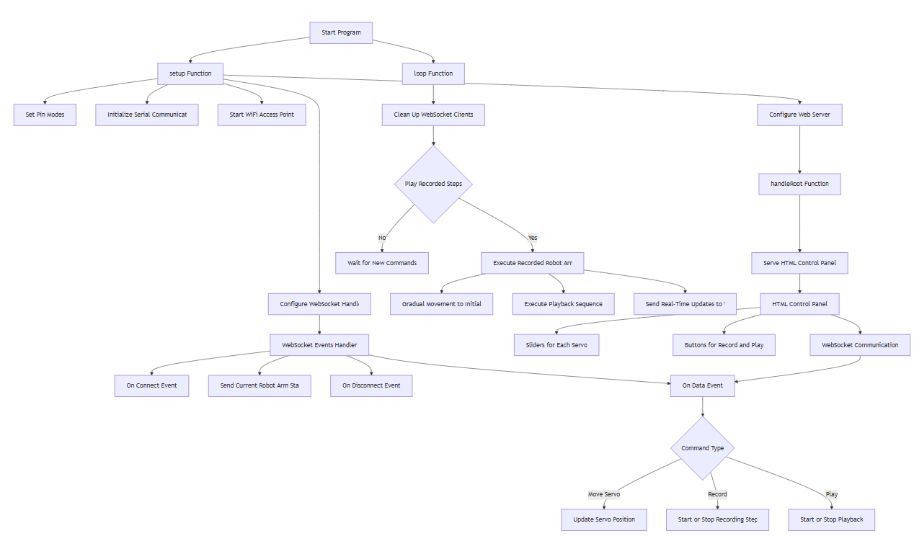**3.4 Workflow Diagram**

Fig.1 Workflow diagram of the Project

The workflow diagram outlines the key steps in the project’s operation. It begins with setting up the Wi-Fi access point and validating clients. The system then configures the server and establishes communication with the HTML control panel. Real-time updates are sent to the control panel, enabling user interaction. The process includes monitoring validated levels, recording and playing movements, and executing payload requests. The workflow ensures seamless communication between the robotic arm and the control interface, facilitating efficient operation and user control.

**3.5 Block Diagram**

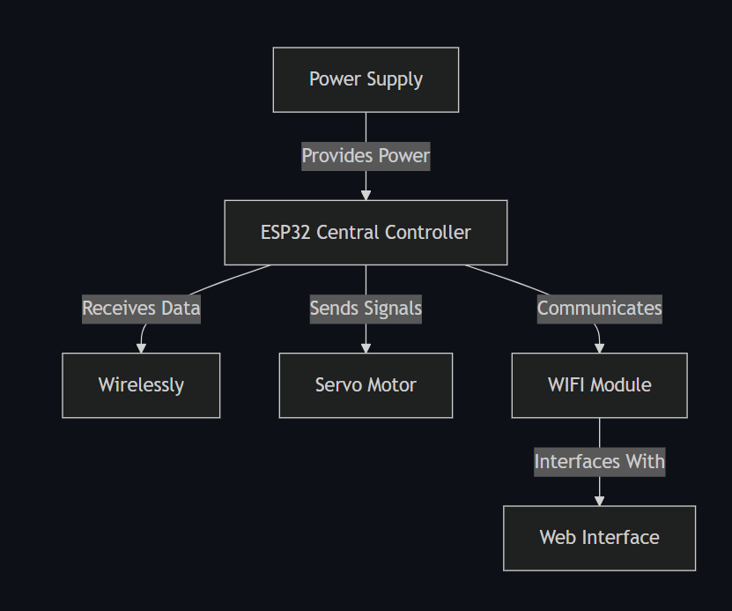

Fig.2 Block diagram of the Project

This diagram illustrates the key components and their interactions in the robotic arm control system. The **Power Supply** provides the necessary energy to run the system. The **ESP32 Central Controller** acts as the brain, receiving data, sending control signals, and managing communication. It connects wirelessly to the **Web Interface** via the **Wi-Fi Module**, enabling remote control. The **Servo Motors** interface with the ESP32 to execute precise movements based on user commands. Together, these components form a cohesive system that allows users to control the robotic arm seamlessly through a web-based interface.

1. **Power Supply**
   * Provides the necessary electrical power to all components, including the ESP32 and servo motors.
   * Ensures stable and consistent operation of the system.
2. **ESP32 Central Controller**
   * Acts as the main processing unit of the system.
   * Receives data from the web interface and sends control signals to the servo motors.
   * Manages communication between the Wi-Fi module and other components.
3. **Wi-Fi Module**
   * Integrated into the ESP32, enabling wireless communication.
   * Facilitates real-time data exchange between the web interface and the ESP32.
4. **Web Interface**
   * A user-friendly control panel developed using HTML, CSS, and JavaScript.
   * Allows users to control the robotic arm remotely via a web browser.
   * Sends commands to the ESP32 and receives real-time updates.
5. **Servo Motors**
   * Connected to the ESP32 and responsible for moving the robotic arm’s joints (Base, Shoulder, Elbow, Gripper).
   * Execute precise movements based on signals received from the ESP32.
6. **Interconnections**
   * The **Power Supply** connects to the ESP32 and servo motors to provide energy.
   * The **ESP32** communicates with the **Web Interface** wirelessly via the **Wi-Fi Module**.
   * The **ESP32** sends control signals to the **Servo Motors** to execute movements.

**3.6 User Interface Based on Web**

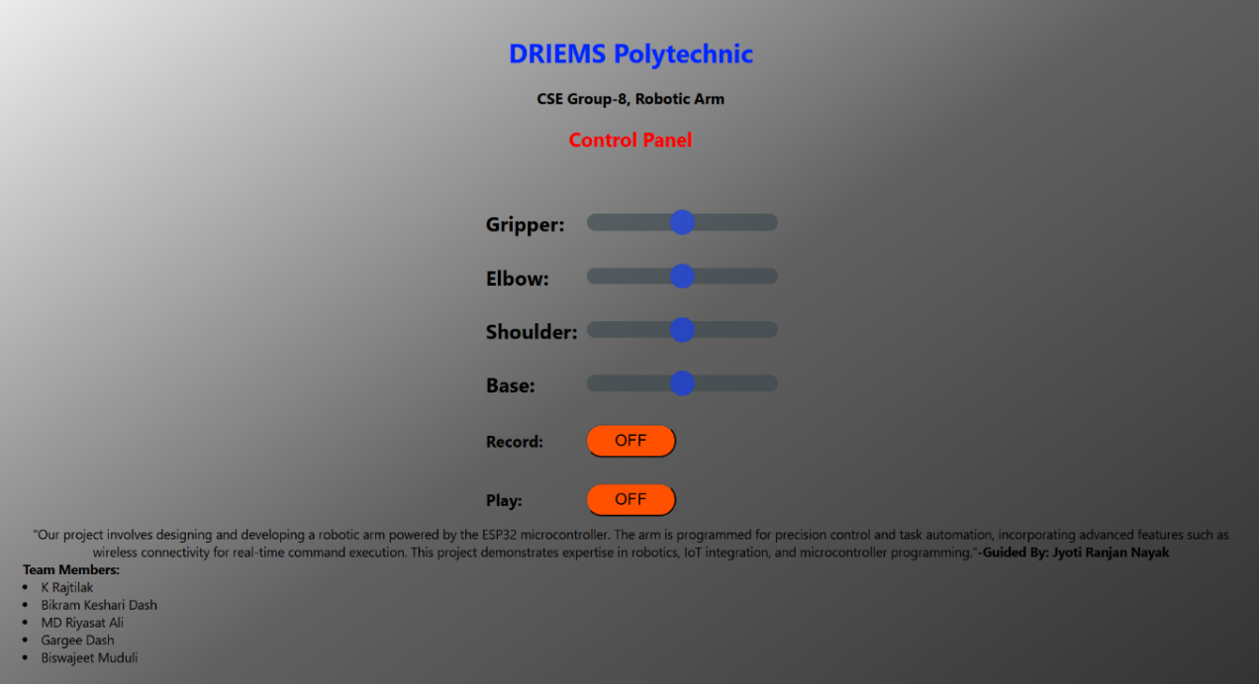

Fig.3 Web Based User Interface

1. **Header Section**
   * Displays the institution name (**DRIEMS Polytechnic**) and project title (**CSE Group-8, Robotic Arm**).
   * Establishes the context and purpose of the interface.
2. **Control Panel Section**
   * Provides sliders for controlling the robotic arm’s joints:
     + **Gripper**: Controls the opening and closing of the arm’s gripper.
     + **Elbow**: Adjusts the elbow joint’s position.
     + **Shoulder**: Manages the shoulder joint’s movement.
     + **Base**: Controls the rotation of the base.
   * Each slider allows real-time adjustments, enabling precise control of the arm’s movements.
3. **Record and Play Buttons**
   * **Record**: Allows users to record a sequence of movements for later playback.
   * **Play**: Plays back the recorded sequence, automating repetitive tasks.
   * Both buttons have an **OFF** state, indicating their default inactive status.
4. **Project Description**
   * A brief description of the project is provided below the control panel.
   * Highlights key features such as:
     + Precision control and task automation.
     + Wireless connectivity for real-time command execution.
     + Integration of robotics, IoT, and microcontroller programming.
5. **Design and Usability**
   * The interface is clean, intuitive, and user-friendly.
   * Sliders and buttons are clearly labeled, making it easy for users to operate the robotic arm.
   * The use of a web-based design ensures accessibility from any device with a browser.
6. **Visual Appeal**
   * The design incorporates a professional and organized layout.
   * The use of headings, sliders, and buttons enhances the visual appeal and usability of the interface.

This web-based UI design effectively combines functionality and aesthetics, providing users with an intuitive and efficient way to control the robotic arm.

**3.7 3D Parts**

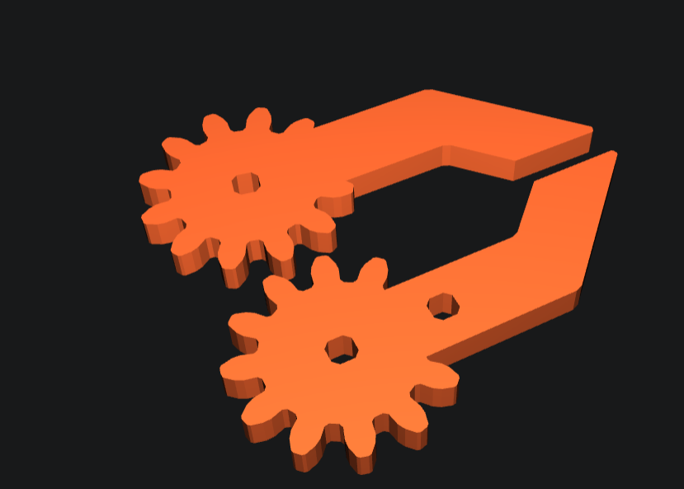

Fig.4 3D Printed Parts

The robotic arm’s body is constructed using **3D printing technology**, with **PLA (Polylactic Acid) plastic** as the primary material and **PETG (Polyethylene Terephthalate Glycol) filament** for added strength and durability. The use of PLA ensures that the body is lightweight, cost-effective, and environmentally friendly, as PLA is derived from renewable resources like cornstarch or sugarcane. PETG, on the other hand, enhances the structural integrity of the arm, providing resistance to impact, heat, and wear, which is essential for the robotic arm’s functionality and longevity.

The body has been designed with precision, featuring **net dimensions of 12.7 cm in length, 12.7 cm in width, and 3.8 cm in height**. These compact dimensions make the robotic arm highly portable and suitable for a variety of applications, including educational demonstrations, small-scale automation, and hobbyist projects. The 3D printing process allows for intricate designs and customization, ensuring that the body accommodates all necessary components, such as the servo motors, ESP32 microcontroller, and wiring, without compromising on stability or performance.

The combination of PLA and PETG materials strikes a balance between lightweight construction and robust durability, making the robotic arm both easy to handle and capable of withstanding the stresses of repeated use. This innovative use of 3D printing technology not only reduces manufacturing costs but also demonstrates the potential of additive manufacturing in creating functional and efficient robotic systems.

**3.8 Final Model**

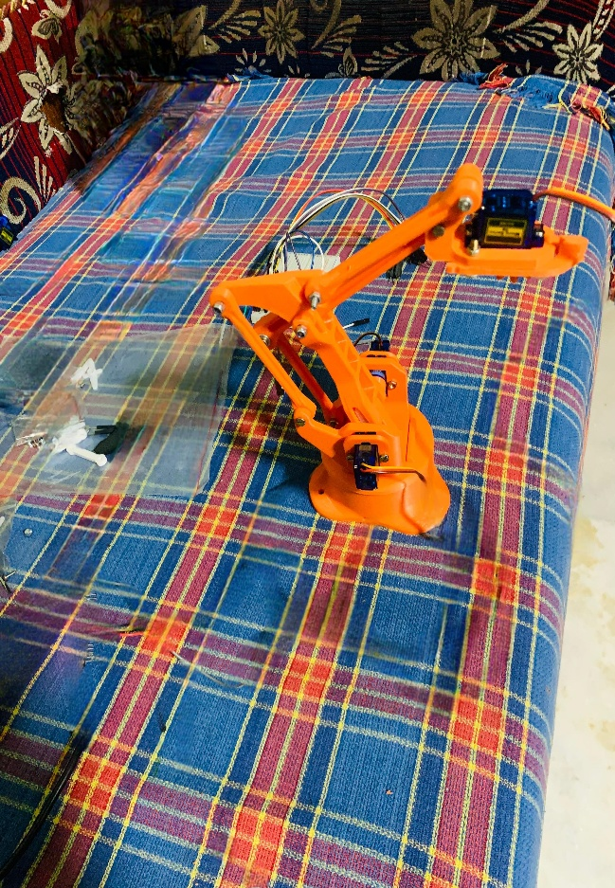

Fig.5 Final Model View

The final model of the robotic arm is a fully assembled, functional system designed for precision control and automation. It features a **3D-printed body** made from PLA plastic and PETG filament, ensuring a lightweight yet durable structure. The arm is powered by **four servo motors** controlling the Base, Shoulder, Elbow, and Gripper, providing smooth and accurate movements. An **ESP32 microcontroller** serves as the central controller, enabling wireless communication via Wi-Fi for real-time control through a **web-based interface**. The system includes advanced features like **recording and playback** of movements, allowing users to automate repetitive tasks. The compact design, with dimensions of **12.7L x 12.7W x 3.8H cm**, makes it portable and versatile for various applications. The integration of hardware and software ensures seamless operation, while the user-friendly interface enhances accessibility. This project showcases expertise in robotics, IoT, and microcontroller programming, making it a practical and innovative solution for automation and educational purposes.

**Chapter 4:**

**IMPLEMENTATION**

**4.1 Code of the project**

**#include <Arduino.h>**

**#include <WiFi.h>**

**#include <AsyncTCP.h>**

**#include <ESPAsyncWebServer.h>**

**#include <ESP32Servo.h>**

**#include <iostream>**

**#include <sstream>**

**struct ServoPins**

**{**

**Servo servo;**

**int servoPin;**

**String servoName;**

**int initialPosition;**

**};**

**std::vector<ServoPins> servoPins =**

**{**

**{ Servo(), 18 , "Base", 90},**

**{ Servo(), 23 , "Shoulder", 90},**

**{ Servo(), 21 , "Elbow", 90},**

**{ Servo(), 22 , "Gripper", 90},**

**};**

**struct RecordedStep**

**{**

**int servoIndex;**

**int value;**

**int delayInStep;**

**};**

**std::vector<RecordedStep> recordedSteps;**

**bool recordSteps = false;**

**bool playRecordedSteps = false;**

**unsigned long previousTimeInMilli = millis();**

**const char* ssid = "RobotArm";**

**const char* password = "12345678"; //The IP address to connect to the web interface - http://192.168.4.1**

**AsyncWebServer server(80);**

**AsyncWebSocket wsRobotArmInput("/RobotArmInput");**

**const char* htmlHomePage PROGMEM = R"HTMLHOMEPAGE(**

**<!DOCTYPE html>**

**<html>**

**<head>**

**<meta name="viewport" content="width=device-width, initial-scale=1, maximum-scale=1, user-scalable=no">**

**<style>**

**body {**

**background: linear-gradient(145deg, #ededed, #626262, #313131);**

**font-family: 'Segoe UI', Tahoma, Geneva, Verdana, sans-serif;**

**min-height: 100vh;**

**align-items: center;**

**justify-content: center;**

**padding: 20px;**

**}**

**input[type=button]**

**{**

**background-color:rgb(255, 81, 0);color:rgb(0, 0, 0);border-radius:30px;width:100%;height:40px;font-size:20px;text-align:center;**

**}**

**.noselect {**

**-webkit-touch-callout: none; /* iOS Safari */**

**-webkit-user-select: none; /* Safari */**

**-khtml-user-select: none; /* Konqueror HTML */**

**-moz-user-select: none; /* Firefox */**

**-ms-user-select: none; /* Internet Explorer/Edge */**

**user-select: none; /* Non-prefixed version, currently**

**supported by Chrome and Opera */**

**}**

**.slidecontainer {**

**width: 100%;**

**}**

**.slider {**

**-webkit-appearance: none;**

**width: 100%;**

**height: 20px;**

**border-radius: 15px;**

**outline: none;**

**opacity: 0.6;**

**-webkit-transition: .2s;**

**transition: opacity .2s;**

**transition: opacity 0.3s ease, transform 0.3s ease, box-shadow 0.3s ease, background-color 0.3s ease;**

**background-color: #3a474c;**

**}**

**.slider:hover {**

**opacity: 1;**

**transform: scale(1.05);**

**box-shadow: 0 8px 20px rgba(0, 0, 0, 0.3);**

**background-color: #ff5733;**

**}**

**.slider::-webkit-slider-thumb {**

**-webkit-appearance: none;**

**appearance: none;**

**width: 30px;**

**height: 30px;**

**border-radius: 50%;**

**background: rgb(0, 51, 255);**

**cursor: pointer;**

**}**

**.slider::-moz-range-thumb {**

**width: 40px;**

**height: 40px;**

**border-radius: 50%;**

**background: red;**

**cursor: pointer;**

**}**

**</style>**

**</head>**

**<div class="container">**

**<body class="noselect" align="center" style="background-color:white">**

**<h1 style="color: rgb(0, 38, 255);text-align:center;">DRIEMS Polytechnic</h1>**

**<h3><b>CSE Group-8, Robotic Arm</b></h3>**

**<h2 style="color: rgb(255, 0, 0);text-align:center;">Control Panel</h2>**

**<table id="mainTable" style="width:380px;margin:auto;table-layout:fixed" CELLSPACING=10>**

**<tr/><tr/>**

**<tr/><tr/>**

**<tr>**

**<td style="text-align:left;font-size:25px"><b>Gripper:</b></td>**

**<td colspan=2>**

**<div class="slidecontainer">**

**<input type="range" min="0" max="180" value="90" class="slider" id="Gripper" oninput='sendButtonInput("Gripper",value)'>**

**</div>**

**</td>**

**</tr>**

**<tr/><tr/>**

**<tr>**

**<td style="text-align:left;font-size:25px"><b>Elbow:</b></td>**

**<td colspan=2>**

**<div class="slidecontainer">**

**<input type="range" min="0" max="180" value="90" class="slider" id="Elbow" oninput='sendButtonInput("Elbow",value)'>**

**</div>**

**</td>**

**</tr>**

**<tr/><tr/>**

**<tr>**

**<td style="text-align:left;font-size:25px"><b>Shoulder:</b></td>**

**<td colspan=2>**

**<div class="slidecontainer">**

**<input type="range" min="0" max="180" value="90" class="slider" id="Shoulder" oninput='sendButtonInput("Shoulder",value)'>**

**</div>**

**</td>**

**</tr>**

**<tr/><tr/>**

**<tr>**

**<td style="text-align:left;font-size:25px"><b>Base:</b></td>**

**<td colspan=2>**

**<div class="slidecontainer">**

**<input type="range" min="0" max="180" value="90" class="slider" id="Base" oninput='sendButtonInput("Base",value)'>**

**</div>**

**</td>**

**</tr>**

**<tr/><tr/>**

**<tr>**

**<td style="text-align:left;font-size:20px"><b>Record:</b></td>**

**<td><input type="button" id="Record" value="OFF" ontouchend='onclickButton(this)'></td>**

**<td></td>**

**</tr>**

**<tr/><tr/>**

**<tr>**

**<td style="text-align:left;font-size:20px"><b>Play:</b></td>**

**<td><input type="button" id="Play" value="OFF" ontouchend='onclickButton(this)'></td>**

**<td></td>**

**</tr>**

**</table>**

**<script>**

**var webSocketRobotArmInputUrl = "ws:\/\/" + window.location.hostname + "/RobotArmInput";**

**var websocketRobotArmInput;**

**function initRobotArmInputWebSocket()**

**{**

**websocketRobotArmInput = new WebSocket(webSocketRobotArmInputUrl);**

**websocketRobotArmInput.onopen = function(event){};**

**websocketRobotArmInput.onclose = function(event){setTimeout(initRobotArmInputWebSocket, 2000);};**

**websocketRobotArmInput.onmessage = function(event)**

**{**

**var keyValue = event.data.split(",");**

**var button = document.getElementById(keyValue[0]);**

**button.value = keyValue[1];**

**if (button.id == "Record" || button.id == "Play")**

**{**

**button.style.backgroundColor = (button.value == "ON" ? "green" : "red");**

**enableDisableButtonsSliders(button);**

**}**

**};**

**}**

**function sendButtonInput(key, value)**

**{**

**var data = key + "," + value;**

**websocketRobotArmInput.send(data);**

**}**

**function onclickButton(button)**

**{**

**button.value = (button.value == "ON") ? "OFF" : "ON" ;**

**button.style.backgroundColor = (button.value == "ON" ? "green" : "red");**

**var value = (button.value == "ON") ? 1 : 0 ;**

**sendButtonInput(button.id, value);**

**enableDisableButtonsSliders(button);**

**}**

**function enableDisableButtonsSliders(button)**

**{**

**if(button.id == "Play")**

**{**

**var disabled = "auto";**

**if (button.value == "ON")**

**{**

**disabled = "none";**

**}**

**document.getElementById("Gripper").style.pointerEvents = disabled;**

**document.getElementById("Elbow").style.pointerEvents = disabled;**

**document.getElementById("Shoulder").style.pointerEvents = disabled;**

**document.getElementById("Base").style.pointerEvents = disabled;**

**document.getElementById("Record").style.pointerEvents = disabled;**

**}**

**if(button.id == "Record")**

**{**

**var disabled = "auto";**

**if (button.value == "ON")**

**{**

**disabled = "none";**

**}**

**document.getElementById("Play").style.pointerEvents = disabled;**

**}**

**}**

**window.onload = initRobotArmInputWebSocket;**

**document.getElementById("mainTable").addEventListener("touchend", function(event){**

**event.preventDefault()**

**});**

**</script>**

**"Our project involves designing and developing a robotic arm powered by the ESP32 microcontroller. The arm is programmed for precision control and task automation, incorporating advanced features such as wireless connectivity for real-time command execution. This project demonstrates expertise in robotics, IoT integration, and microcontroller programming."<b>-Guided By: Jyoti Ranjan Nayak</b></div>**

**<div style="text-align:left;">**

**<b>Team Members:</b>**

**<li>K Rajtilak</li>**

**<li>Bikram Keshari Dash</li>**

**<li>MD Riyasat Ali</li>**

**<li>Gargee Dash</li>**

**<li>Biswajeet Muduli</li>**

**</div>**

**</body>**

**</html>**

**)HTMLHOMEPAGE";**

**void handleRoot(AsyncWebServerRequest *request)**

**{**

**request->send_P(200, "text/html", htmlHomePage);**

**}**

**void handleNotFound(AsyncWebServerRequest *request)**

**{**

**request->send(404, "text/plain", "File Not Found");**

**}**

**void onRobotArmInputWebSocketEvent(AsyncWebSocket *server,**

**AsyncWebSocketClient *client,**

**AwsEventType type,**

**void *arg,**

**uint8_t *data,**

**size_t len)**

**{**

**switch (type)**

**{**

**case WS_EVT_CONNECT:**

**Serial.printf("WebSocket client #%u connected from %s\n", client->id(), client->remoteIP().toString().c_str());**

**sendCurrentRobotArmState();**

**break;**

**case WS_EVT_DISCONNECT:**

**Serial.printf("WebSocket client #%u disconnected\n", client->id());**

**break;**

**case WS_EVT_DATA:**

**AwsFrameInfo *info;**

**info = (AwsFrameInfo*)arg;**

**if (info->final && info->index == 0 && info->len == len && info->opcode == WS_TEXT)**

**{**

**std::string myData = "";**

**myData.assign((char *)data, len);**

**std::istringstream ss(myData);**

**std::string key, value;**

**std::getline(ss, key, ',');**

**std::getline(ss, value, ',');**

**Serial.printf("Key [%s] Value[%s]\n", key.c_str(), value.c_str());**

**int valueInt = atoi(value.c_str());**

**if (key == "Record")**

**{**

**recordSteps = valueInt;**

**if (recordSteps)**

**{**

**recordedSteps.clear();**

**previousTimeInMilli = millis();**

**}**

**}**

**else if (key == "Play")**

**{**

**playRecordedSteps = valueInt;**

**}**

**else if (key == "Base")**

**{**

**writeServoValues(0, valueInt);**

**}**

**else if (key == "Shoulder")**

**{**

**writeServoValues(1, valueInt);**

**}**

**else if (key == "Elbow")**

**{**

**writeServoValues(2, valueInt);**

**}**

**else if (key == "Gripper")**

**{**

**writeServoValues(3, valueInt);**

**}**

**}**

**break;**

**case WS_EVT_PONG:**

**case WS_EVT_ERROR:**

**break;**

**default:**

**break;**

**}**

**}**

**void sendCurrentRobotArmState()**

**{**

**for (int i = 0; i < servoPins.size(); i++)**

**{**

**wsRobotArmInput.textAll(servoPins[i].servoName + "," + servoPins[i].servo.read());**

**}**

**wsRobotArmInput.textAll(String("Record,") + (recordSteps ? "ON" : "OFF"));**

**wsRobotArmInput.textAll(String("Play,") + (playRecordedSteps ? "ON" : "OFF"));**

**}**

**void writeServoValues(int servoIndex, int value)**

**{**

**if (recordSteps)**

**{**

**RecordedStep recordedStep;**

**if (recordedSteps.size() == 0) // We will first record initial position of all servos.**

**{**

**for (int i = 0; i < servoPins.size(); i++)**

**{**

**recordedStep.servoIndex = i;**

**recordedStep.value = servoPins[i].servo.read();**

**recordedStep.delayInStep = 0;**

**recordedSteps.push_back(recordedStep);**

**}**

**}**

**unsigned long currentTime = millis();**

**recordedStep.servoIndex = servoIndex;**

**recordedStep.value = value;**

**recordedStep.delayInStep = currentTime - previousTimeInMilli;**

**recordedSteps.push_back(recordedStep);**

**previousTimeInMilli = currentTime;**

**}**

**servoPins[servoIndex].servo.write(value);**

**}**

**void playRecordedRobotArmSteps()**

**{**

**if (recordedSteps.size() == 0)**

**{**

**return;**

**}**

**//This is to move servo to initial position slowly. First 4 steps are initial position**

**for (int i = 0; i < 4 && playRecordedSteps; i++)**

**{**

**RecordedStep &recordedStep = recordedSteps[i];**

**int currentServoPosition = servoPins[recordedStep.servoIndex].servo.read();**

**while (currentServoPosition != recordedStep.value && playRecordedSteps)**

**{**

**currentServoPosition = (currentServoPosition > recordedStep.value ? currentServoPosition - 1 : currentServoPosition + 1);**

**servoPins[recordedStep.servoIndex].servo.write(currentServoPosition);**

**wsRobotArmInput.textAll(servoPins[recordedStep.servoIndex].servoName + "," + currentServoPosition);**

**delay(50);**

**}**

**}**

**delay(2000); // Delay before starting the actual steps.**

**for (int i = 4; i < recordedSteps.size() && playRecordedSteps ; i++)**

**{**

**RecordedStep &recordedStep = recordedSteps[i];**

**delay(recordedStep.delayInStep);**

**servoPins[recordedStep.servoIndex].servo.write(recordedStep.value);**

**wsRobotArmInput.textAll(servoPins[recordedStep.servoIndex].servoName + "," + recordedStep.value);**

**}**

**}**

**void setUpPinModes()**

**{**

**for (int i = 0; i < servoPins.size(); i++)**

**{**

**servoPins[i].servo.attach(servoPins[i].servoPin);**

**servoPins[i].servo.write(servoPins[i].initialPosition);**

**}**

**}**

**void setup(void)**

**{**

**setUpPinModes();**

**Serial.begin(115200);**

**WiFi.softAP(ssid, password);**

**IPAddress IP = WiFi.softAPIP();**

**Serial.print("AP IP address: ");**

**Serial.println(IP);**

**server.on("/", HTTP_GET, handleRoot);**

**server.onNotFound(handleNotFound);**

**wsRobotArmInput.onEvent(onRobotArmInputWebSocketEvent);**

**server.addHandler(&wsRobotArmInput);**

**server.begin();**

**Serial.println("HTTP server started");**

**}**

**void loop()**

**{**

**wsRobotArmInput.cleanupClients();**

**if (playRecordedSteps)**

**{**

**playRecordedRobotArmSteps();**

**}**

**}**

**CHAPTER 5:**

**5.1 Result Analysis**

The developed wireless robotic arm control system was tested extensively to evaluate its performance across various metrics, including responsiveness, precision, usability, and stability. The results demonstrate that the system meets the intended objectives and performs reliably in real-time applications.

One of the key achievements is the successful **real-time control** of all four degrees of freedom (Base, Shoulder, Elbow, and Gripper) through a web-based interface. The system exhibited **low-latency communication** between the ESP32 microcontroller and the web UI using the WebSocket protocol, allowing for smooth movement without noticeable delay. The servo motors responded accurately to slider inputs from the user interface, validating the effectiveness of the control algorithms and the WebSocket implementation.

The **record and playback** functionality performed well in replicating predefined sequences. During testing, multiple sequences were recorded and replayed consistently, confirming the robustness of the movement storage and execution logic. This feature proves highly beneficial in automating repetitive tasks, as the arm can execute complex motion patterns without manual re-input.

The **user interface** was tested on various devices, including laptops, tablets, and smartphones. It retained full functionality and displayed correctly across all screen sizes, affirming its responsive design. Users reported the interface as intuitive and easy to operate, even without prior knowledge of robotics or programming.

**Power consumption and heat management** were also observed. The use of a 5V regulated power supply ensured stable operation of the ESP32 and servos, with minimal heating issues, highlighting the efficiency of the chosen hardware setup.

In conclusion, the project successfully demonstrates a cost-effective, real-time, web-controlled robotic arm with practical features. The results confirm that the system is not only functional but also scalable for educational and industrial applications.

**5.2 Comparison**

The proposed wireless robotic arm control system introduces several improvements over traditional robotic systems, especially in terms of control flexibility, usability, and cost-effectiveness. While conventional systems often rely on wired connections and pre-programmed sequences, this project uses a web-based interface with real-time control through the ESP32’s Wi-Fi capabilities. This shift allows users to interact with the robotic arm wirelessly, enabling mobility and ease of use.

Another major difference lies in the user interface. Traditional systems typically lack a dedicated UI or require complex software installations. In contrast, the proposed system features a visually appealing and intuitive web interface accessible from any device with a browser, enhancing accessibility for non-technical users. Additionally, features like movement recording and playback, which are rarely available in basic robotic arm kits, are seamlessly integrated in this project. These features enable users to automate repetitive tasks with minimal effort.

Cost is another important factor. While many existing robotic systems use expensive proprietary hardware, the proposed system is built using cost-effective and open-source components like the ESP32 and standard servo motors. This makes the project more affordable and scalable for educational institutions and small businesses. Overall, the system offers improved mobility, automation capability, and user-friendliness at a fraction of the cost compared to many commercial systems.

• Control **Mechanism:**

* Traditional systems rely on pre-programmed or manual control using wired setups.
* The proposed system offers real-time, wireless control using a responsive web interface.

• Communication **Medium:**

* Conventional systems use USB or serial wired communication.
* The proposed project uses Wi-Fi via the ESP32 and WebSocket protocol for seamless, wireless interaction.

• User **Interface:**

* Existing systems often require additional software or complex interfaces.
* The new system uses an intuitive, platform-independent web interface that works on all devices with browsers.

• Automation **Features:**

* Recording and playback features are typically unavailable in basic models.
* The proposed system includes easy-to-use record and plays functions for automating repetitive tasks.

• Cost**-Effectiveness:**

* Traditional systems can be costly due to proprietary hardware and software.
* The proposed system uses affordable components, making it ideal for students, hobbyists, and small businesses.

• Flexibility **and Portability:**

* Wired systems limit movement and require a constant connection.
* Wireless control allows greater flexibility and portability in real-world applications.

• Scalability**:**

* Traditional systems may not be easy to modify or extend.
* The open-source nature of this project supports easy upgrades and additional features.

**5.3 Advantages**

The proposed wireless robotic arm control system offers numerous advantages that enhance its overall functionality, accessibility, and relevance in both educational and practical applications. One of the primary benefits is its wireless operation using the ESP32 microcontroller. This eliminates the need for physical connections, allowing the robotic arm to be used in a wider range of environments with greater freedom of movement. The inclusion of a web-based interface developed using HTML, CSS, and JavaScript ensures that the system is platform-independent, enabling users to control the robotic arm from any device with a browser, such as a smartphone, tablet, or laptop, without the need for additional software.

Another major advantage is the integration of recording and playback functionality, which allows users to automate repetitive tasks with ease. This feature not only saves time but also ensures consistency and accuracy in operations, making it suitable for educational demonstrations and small-scale industrial use. The system’s user interface is designed to be intuitive and visually appealing, making it accessible even to users with minimal technical background. This ease of use lowers the learning curve and encourages experimentation and learning, especially among students and hobbyists.

Cost-effectiveness is also a key strength of this system. By utilizing affordable components such as the ESP32 and standard servo motors, the overall project remains budget-friendly without compromising on performance. This makes it an ideal solution for institutions and individuals looking to explore robotics without significant financial investment. Furthermore, the open-source nature of the hardware and software provides flexibility for future upgrades and customization, allowing users to add new features such as voice control, AI integration, or additional sensors.

In summary, the system's wireless communication, ease of use, automation capabilities, low cost, and expandability make it a powerful and practical solution for real-world applications. These advantages position the project as an innovative and accessible tool for learning, experimentation, and deployment in modern robotics.

**5.4 Disadvantages**

While the proposed wireless robotic arm control system offers several benefits, it also has certain limitations and disadvantages that must be acknowledged. One of the primary drawbacks is the limited degrees of freedom. The system is designed with only four degrees of freedom (Base, Shoulder, Elbow, and Gripper), which restricts its range of motion and the complexity of tasks it can perform. This makes it unsuitable for applications that require intricate or highly flexible movements, such as those found in advanced manufacturing or surgical robotics.

Another disadvantage is the dependence on Wi-Fi connectivity. Since the system relies on the ESP32’s wireless capabilities and a browser-based interface, it is highly dependent on stable Wi-Fi communication. In environments with poor signal strength or interference, the system’s performance may degrade, leading to delayed responses or disconnections. This could affect the reliability of the robotic arm in real-time operations, especially in time-sensitive applications.

Additionally, the servo motors used in the system, while cost-effective, may lack the torque and precision needed for handling heavier loads or performing tasks that require high mechanical strength. They can also generate heat and jitter if operated continuously or under stress, which might reduce the system’s longevity or cause calibration issues. Power limitations could also arise, as the entire system relies on a single 5V supply, which may not be sufficient for high-load or long-duration operations.

The recording and playback functionality, although useful, is relatively basic. It lacks features like speed control, error correction, or real-time editing, which would be necessary for more advanced automation tasks. Moreover, the system does not incorporate any form of feedback or sensor input, such as encoders or position sensors, making it a purely open-loop control system. This means it cannot automatically detect or correct positional errors, which could reduce accuracy over time or after repeated operations.

In conclusion, while the project is highly effective for educational and small-scale applications, it has limitations in terms of mechanical capability, control accuracy, and environmental dependency. These disadvantages highlight areas for future improvement, including the integration of feedback mechanisms, stronger actuators, and more robust connectivity options.

**5.5 Maintenance**

Regular maintenance is essential to ensure the long-term functionality, accuracy, and safety of the wireless robotic arm control system. Since the system involves a combination of mechanical, electronic, and software components, a consistent maintenance schedule helps prevent unexpected failures and prolongs the lifespan of the device. The primary mechanical components—servo motors and 3D-printed joints—should be periodically inspected for wear and tear. Servo motors, especially, are prone to overheating and mechanical fatigue after prolonged usage. Ensuring that the arm is not overloaded and that the motors are calibrated correctly can prevent jittering and improve overall performance.

The 3D-printed parts made from PLA and PETG should be checked for cracks, loosening, or deformation over time, particularly if the system is used frequently or in high-temperature environments. If any parts are damaged or show signs of stress, they should be reprinted and replaced promptly to avoid operational issues. Additionally, screws and connectors holding the structural components together must be tightened regularly to maintain alignment and prevent instability during movement.

On the electronics side, the ESP32 microcontroller and power supply should be monitored to ensure they are functioning correctly. Dust accumulation on the circuit board or power ports can lead to short circuits or unreliable connections. It is recommended to clean the electronic components with a soft brush or compressed air and avoid exposing the system to moisture. The wiring and connections between the ESP32, servos, and power source must also be checked regularly for any signs of loosening, corrosion, or damage.

Software maintenance involves updating the firmware or Arduino code on the ESP32 if any bugs are found or new features are added. The web-based interface should also be tested periodically across different browsers and devices to ensure continued compatibility. Backup copies of the code, movement sequences, and configurations should be stored securely in case of data loss or corruption.

In summary, proper maintenance of both hardware and software is crucial for the efficient and safe operation of the robotic arm. By following routine inspection and care practices, users can ensure the system remains reliable and performs as intended over time.

**5.5 Output**

**Protocol and Controller Performance Metrics:**

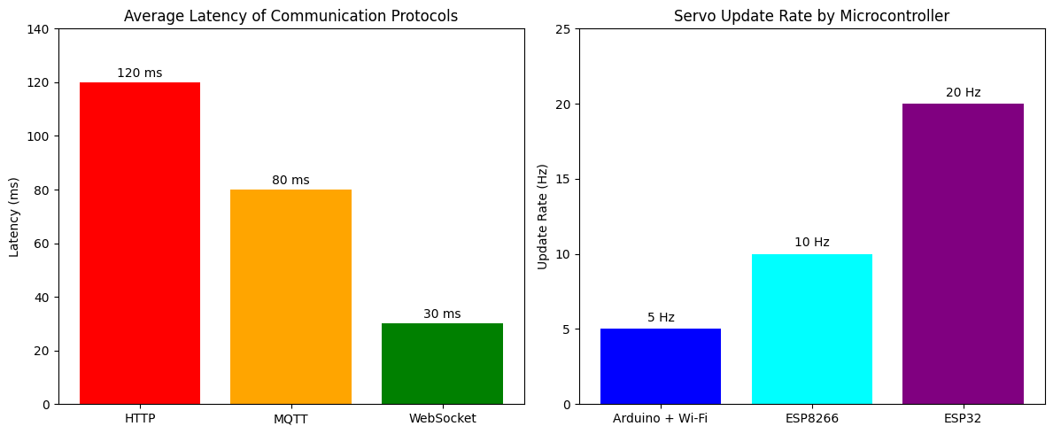

**System Latency Across Varying Network Conditions:**

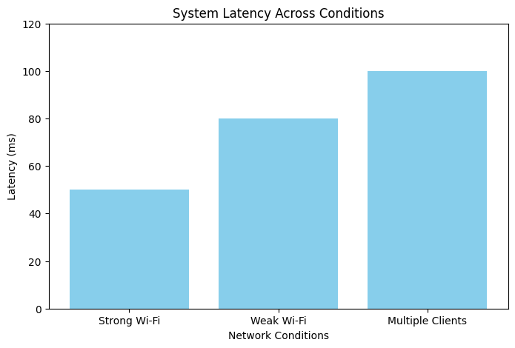

**Protocol Performance: Response Time Comparison:**

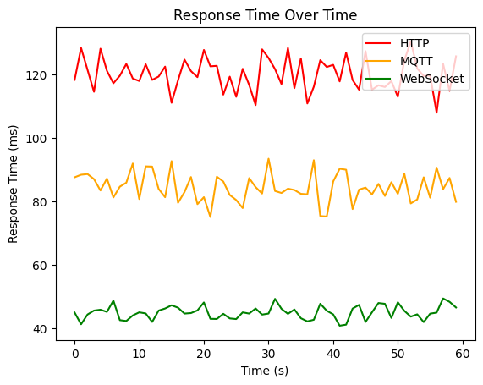

**CPU Task Load Distribution on ESP32 Microcontroller:**

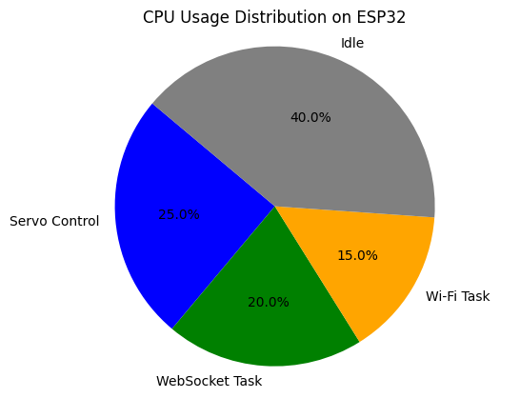

**CHAPTER 6:**

**Conclusion & Future Work**

The wireless robotic arm control system, a 4-degree-of-freedom (4-DOF) solution driven by an ESP32 microcontroller, represents a significant advancement in the integration of robotics, Internet of Things (IoT), and user-centric design, successfully achieving its objectives of delivering precise, real-time wireless control through an intuitive web interface developed using HTML, CSS, and JavaScript. This project has demonstrated its potential to address real-world challenges by enabling seamless automation and flexibility across diverse applications, including industrial manufacturing, healthcare, education, and small-scale automation. The system’s lightweight and durable 3D-printed body, constructed from PLA and PETG materials with compact dimensions of 12.7 x 12.7 x 3.8 cm, ensures portability and robustness, making it suitable for educational demonstrations, hobbyist projects, and professional use. By leveraging the ESP32’s built-in Wi-Fi capabilities and the WebSocket protocol, the system facilitates low-latency, bidirectional communication, allowing users to control the robotic arm’s joints (Base, Shoulder, Elbow, and Gripper) with high precision through sliders on a visually appealing web interface. Advanced features, such as recording and playback of movement sequences, enable automation of repetitive tasks, enhancing efficiency and reducing human error. Rigorous testing and validation, including functional, integration, and user testing, confirmed the system’s reliability, responsiveness, and ease of use, with optimizations resolving challenges like servo jitter and communication latency. The use of affordable components, such as the ESP32 and standard servo motors, combined with open-source Arduino programming, ensures cost-effectiveness, making the system accessible to a wide audience, including students, small businesses, and researchers. The project’s educational value is profound, providing hands-on learning opportunities in robotics, microcontroller programming, web development, and IoT, fostering interdisciplinary skills like problem-solving and critical thinking. Its societal impact is equally significant, empowering small businesses with cost-effective automation, enhancing quality of life through potential assistive applications for individuals with mobility challenges, and promoting resource efficiency by minimizing errors and waste in automated tasks. Looking ahead, future enhancements could significantly expand the system’s capabilities and impact. Integrating machine learning and artificial intelligence, such as reinforcement learning or computer vision, could enable autonomous task optimization and object recognition, making the arm suitable for complex applications like pick-and-place operations or autonomous sorting in dynamic environments. Adding sensors, such as force or proximity detectors, would enhance the arm’s ability to interact safely and effectively with its surroundings, critical for delicate tasks in healthcare or industrial settings. Increasing the degrees of freedom to 6-DOF would allow for more intricate movements, broadening applications to advanced surgical procedures or detailed assembly tasks. Power efficiency improvements, such as energy-efficient algorithms or alternative power sources like rechargeable batteries, could enhance portability for remote applications like agriculture or space exploration. Developing a dedicated mobile application would complement the web interface, offering touch-based controls for greater user convenience. Cloud integration for data storage, remote monitoring, and predictive maintenance could enable advanced analytics and scalability, while robust error-handling and fault-tolerant designs would improve reliability in industrial settings. Sharing the project’s code and designs with the open-source community could foster collaboration and innovation, encouraging further development by researchers and hobbyists. Finally, deploying the system in real-world scenarios, such as small-scale manufacturing, educational workshops, or assistive technology for individuals with disabilities, would provide valuable feedback to refine performance and validate its practical utility. By pursuing these avenues, the robotic arm control system can evolve into a more advanced, versatile, and impactful platform, contributing to the ongoing development of robotics and automation technologies while maintaining its foundation in accessibility, affordability, and user-friendly design.

**References**

1. Kurbanhusen Mustafa, S., Yang, G., Huat Yeo, S., Lin, W. and Chen, M., 2008. Self-calibration of a biologically inspired 7 DOF cable-driven robotic arm. Mechatronics, IEEE/ASME Transactions on, 13(1), pp.66- 75.
2. Kim, H.S., Min, J.K. and Song, J.B., 2016. Multiple-Degree-of-Freedom Counterbalance Robot Arm Based on Slider-Crank Mechanism and Bevel Gear Units. IEEE Transactions on Robotics, 32(1), pp.230-235.
3. Kim, H.J., Tanaka, Y., Kawamura, A., Kawamura, S. and Nishioka, Y., 2015, August. Development of an inflatable robotic arm system controlled by a joystick. In Robot and Human Interactive Communication (RO-MAN), 2015 24th IEEE International Symposium on (pp. 664-669). IEEE.
4. Mohammed, A.A. and Sunar, M., 2015, May. Kinematics modeling of a 4-DOF robotic arm. In Control, Automation and Robotics (ICCAR), 2015 International Conference on (pp. 87-91). IEEE.
5. Siciliano, B., 2009. Robotics. London: Springer
6. Zhang, Z., 2015. Wearable sensor technologies applied for post-stroke rehabilitation (Doctoral dissertation, RMIT University).
7. Qassem, M.A., Abuhadrous, I. and Elaydi, H., 2010, March. Modeling and Simulation of 5 DOF educational robot arm. In Advanced Computer Control (ICACC), 2010 2nd International Conference on (Vol. 5, pp. 569-574). IEEE.
8. Bhuyan, A.I. and Mallick, T.C., 2014, October. Gyro-accelerometer based control of a robotic Arm using AVR microcontroller. In Strategic Technology (IFOST), 2014 9th International Forum on (pp. 409-413). IEEE.
9. Anon, 2016. The Ninth International Symposium. [online] Robotics Research. Available at: [http://Robotics](http://robotics/) Research: The Ninth International Symposium [Accessed 4 Apr. 2016]
10. Condit, R. and Jones, D.W., 2004. Stepping motors fundamentals. Microchip Application Note: AN907,[Online]. Available: [www.microchip.com](http://www.microchip.com/)
11. Yang, G., Lin, W., Kurbanhusen Mustafa, S., Pham, C. B., & Yeo, S. H. (2005). Kinematic design of a 7-DOF cable-driven humanoid arm: A solution-in-nature approach. In Proceedings of the IEEE/ASME International Conference on Advanced Intelligent Mechatronics (AIM) (pp. 24-28). Monterey, CA: IEEE.
12. Rodić, A., Hioki, S., Radmilović, M., & Jovanović, M. (2020). Mechanical design, modeling and simulation of human-size cable-driven over-actuated robotic arm. In K. Berns & D. Görges (Eds.), Advances in Service and Industrial Robotics, RAAD 2019 (pp. 56-64). Cham: Springer.
13. Ohta, P., Valle, L., King, J., Low, K., Yi, J., Atkeson, C. G., & Park, Y. L. (2018). Design of a lightweight soft robotic arm using pneumatic artificial muscles and inflatable sleeves. Soft Robotics, 5(2), 204-215.
14. Mohammed, N. A., Azar, A. T., Abbas, N. E., Ezzeldin, M. A., & Ammar, H. H. (2020). Experimental kinematic modeling of 6-DOF serial manipulator using hybrid deep learning. In Proceedings of the International Conference on Artificial Intelligence and Computer Vision (AICV2020) (pp. 283-295). Cham: Springer.
15. Mao, Y., & Agrawal, S. K. (2012). Design of a cable-driven arm exoskeleton (CAREX) for neural rehabilitation. IEEE Transactions on Robotics, 28(4), 922-931.
16. Crenganis, M., Breaz, R., Racz, S. G., & Bologa, O. (2021). Dynamic analysis of a five degree of freedom robotic arm using MATLAB-Simulink Simscape. MATEC Web of Conferences, 343, 04002.
17. Pang, Z., Liu, S., Wang, Z., & Gong, L. (2020). Kinematics analysis of 7-DOF upper limb rehabilitation robot based on BP neural network. In 2020 IEEE 9th Data Driven Control and Learning Systems Conference (DDCLS) (pp. 123-128). Liuzhou, China: IEEE.
18. Fu, S., & Bhavsar, P. C. (2020). Robotic arm control based on Internet of Things. In 2020 IEEE Long Island Systems, Applications and Technology Conference (LISAT) (pp. 1-6). Farmingdale, NY: IEEE.
19. Wang, H., Chen, W., Yu, X., Deng, T., Wang, X., & Pfeifer, R. (2013). Visual servo control of cable-driven soft robotic manipulator. In 2013 IEEE/RSJ International Conference on Intelligent Robots and Systems (IROS) (pp. 57-62). Tokyo, Japan: IEEE.
20. Adediran, E. M., Fadare, D. A., Falana, A., Kazeem, R. A., Ikumapayi, O. M., Adedayo, A. S., Adetunla, A. O., Ifebunandu, U. J., Fadare, D. A., & Olarinde, E. S. (2023). Uiarm i: Development of a low-cost and modular 4-DOF robotic arm for sorting plastic bottles from waste stream. Journal Européen des Systèmes Automatisés, 56(3), 97-100.